TGAM Welding Tutorials
1.Materials preparing:
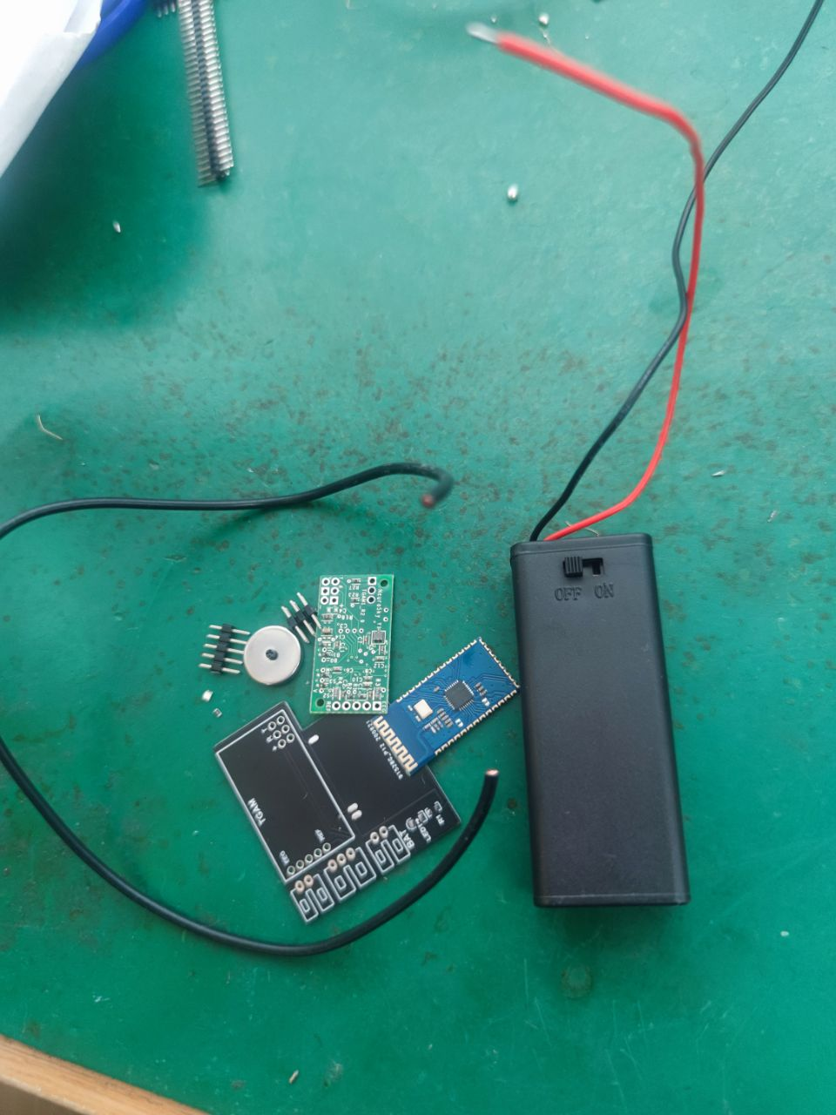
2.Weld the resistors and LED lights to the position shown on the board as shown.
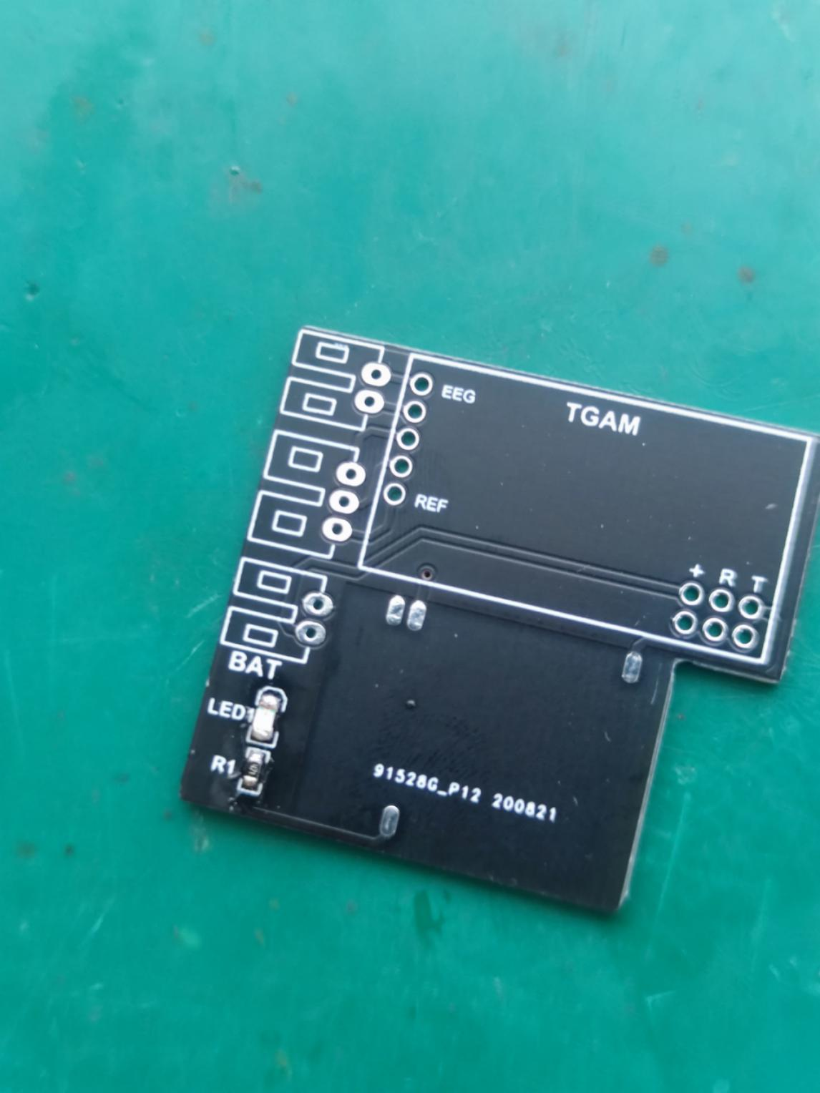
- Weld the pins to the position shown on the board as shown.
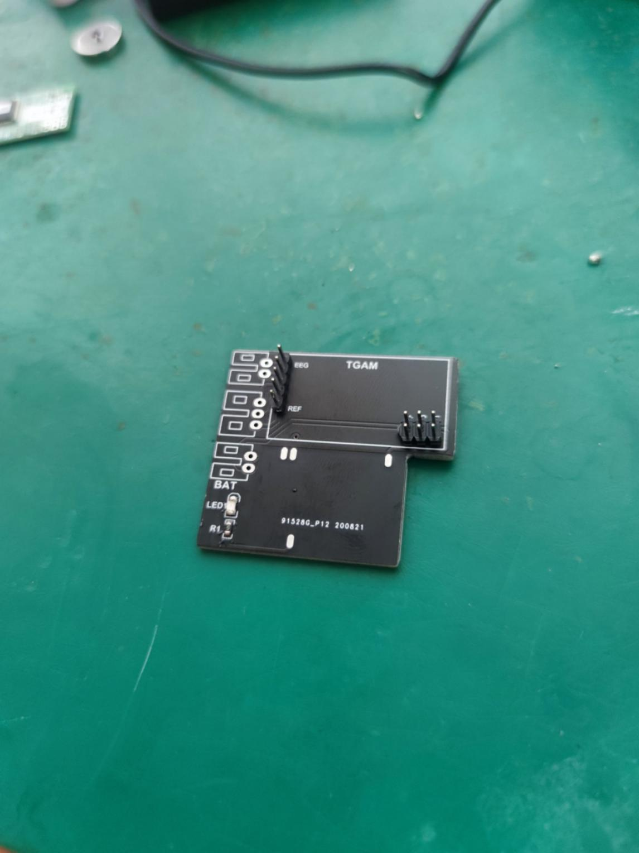
4.Then put the TGAM chip onto the pins as shown.
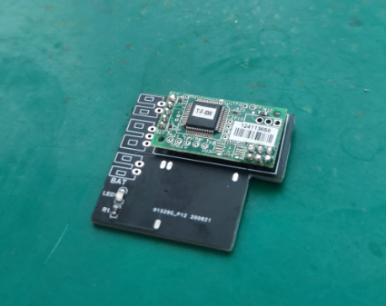
5.Take out the shielding wire, peel off the cover of the part of shield on both sides
.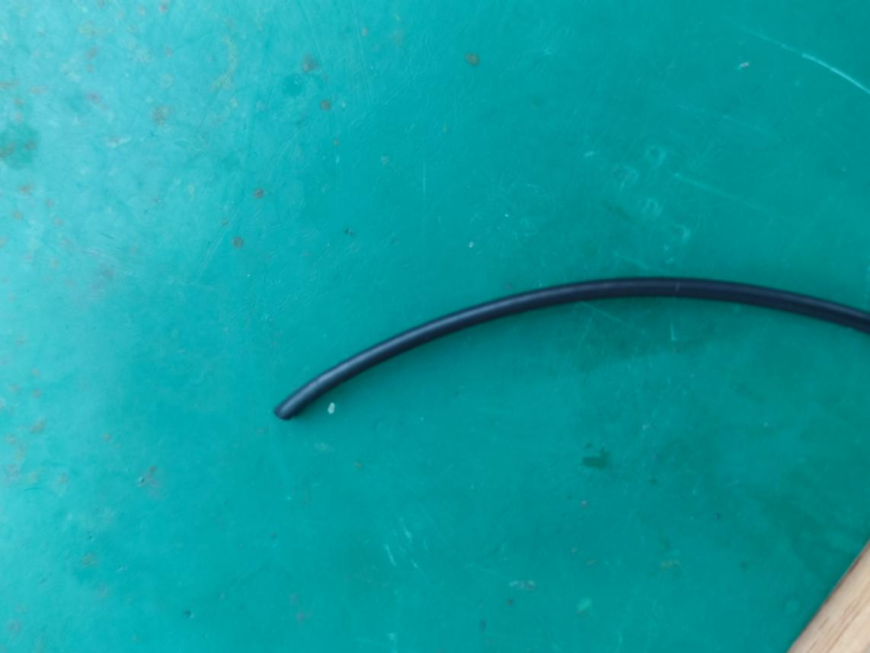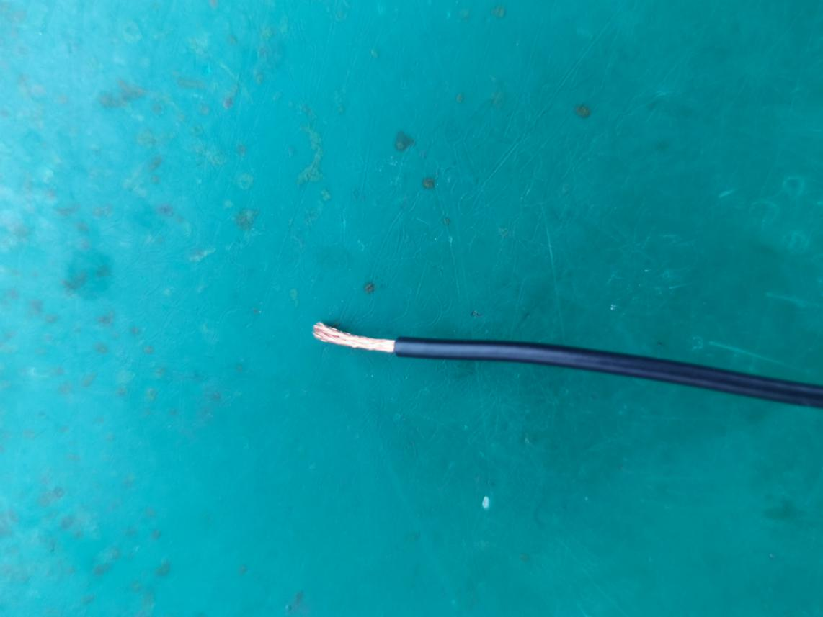
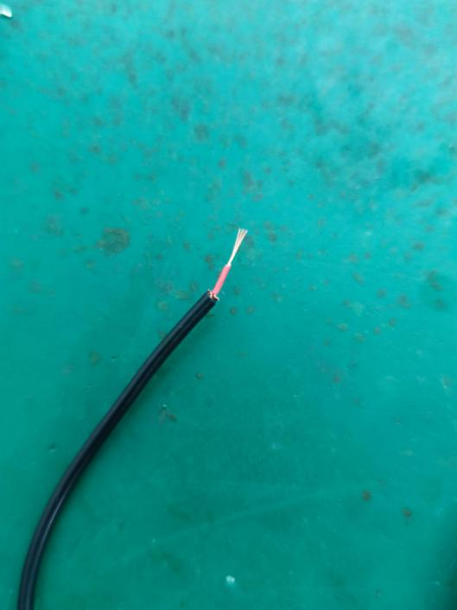
- Take out the electrode and weld the wires and electrodes together.
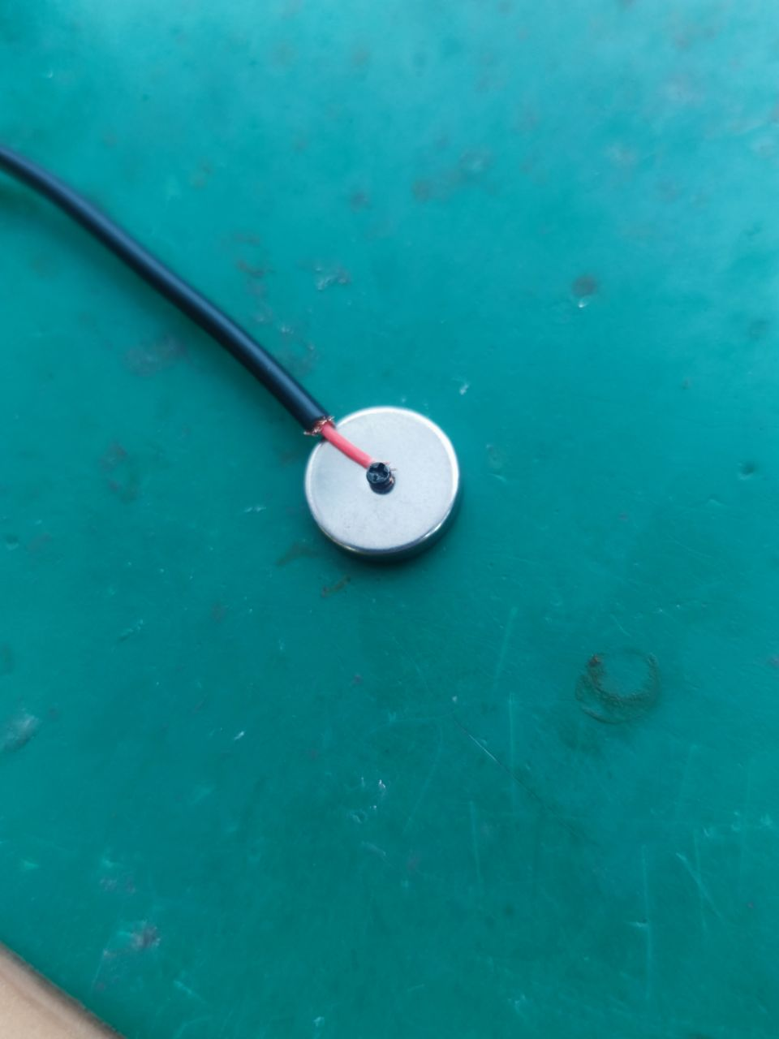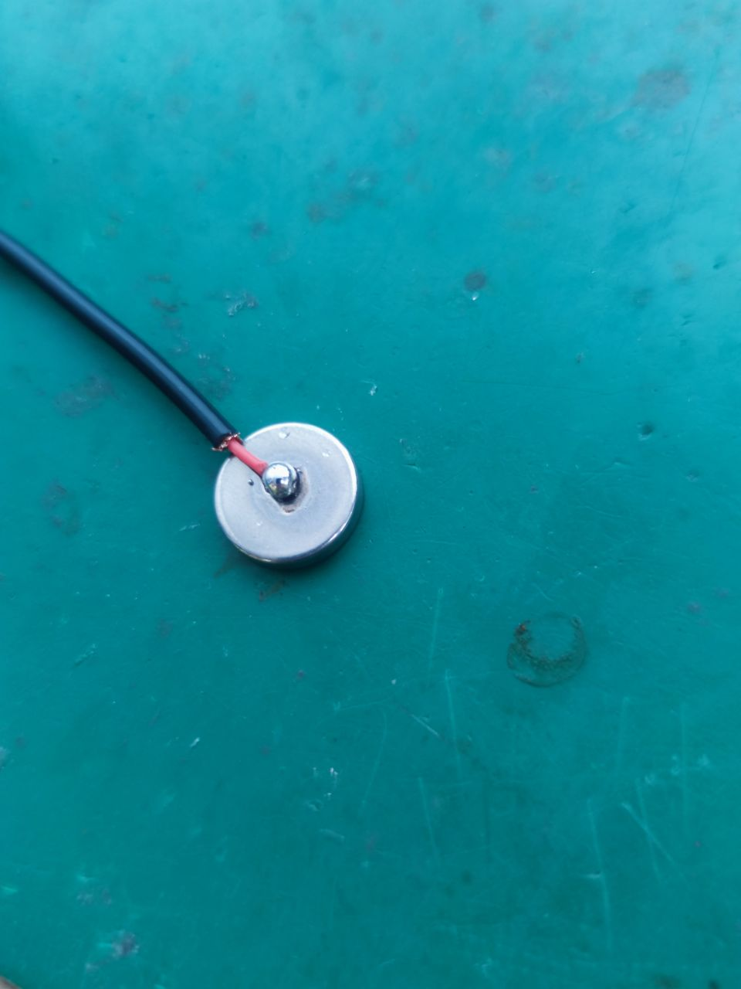
- The other side of the shielding wire, divide the line into two ends. And then weld it to the pin as shown.
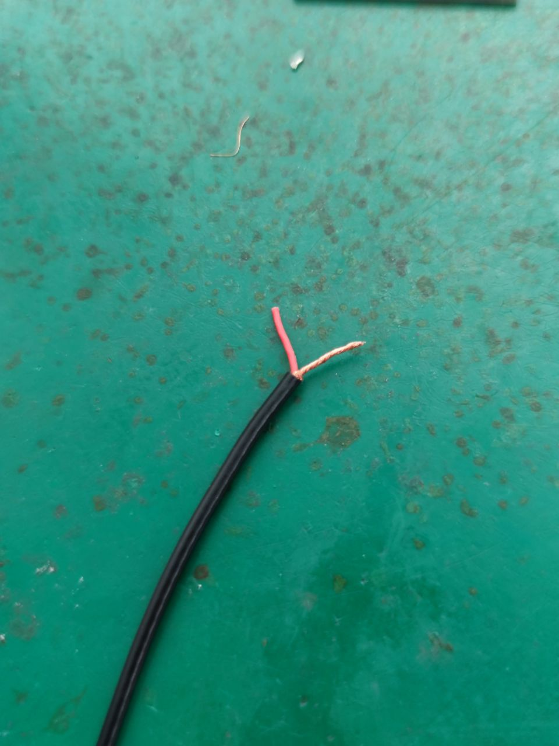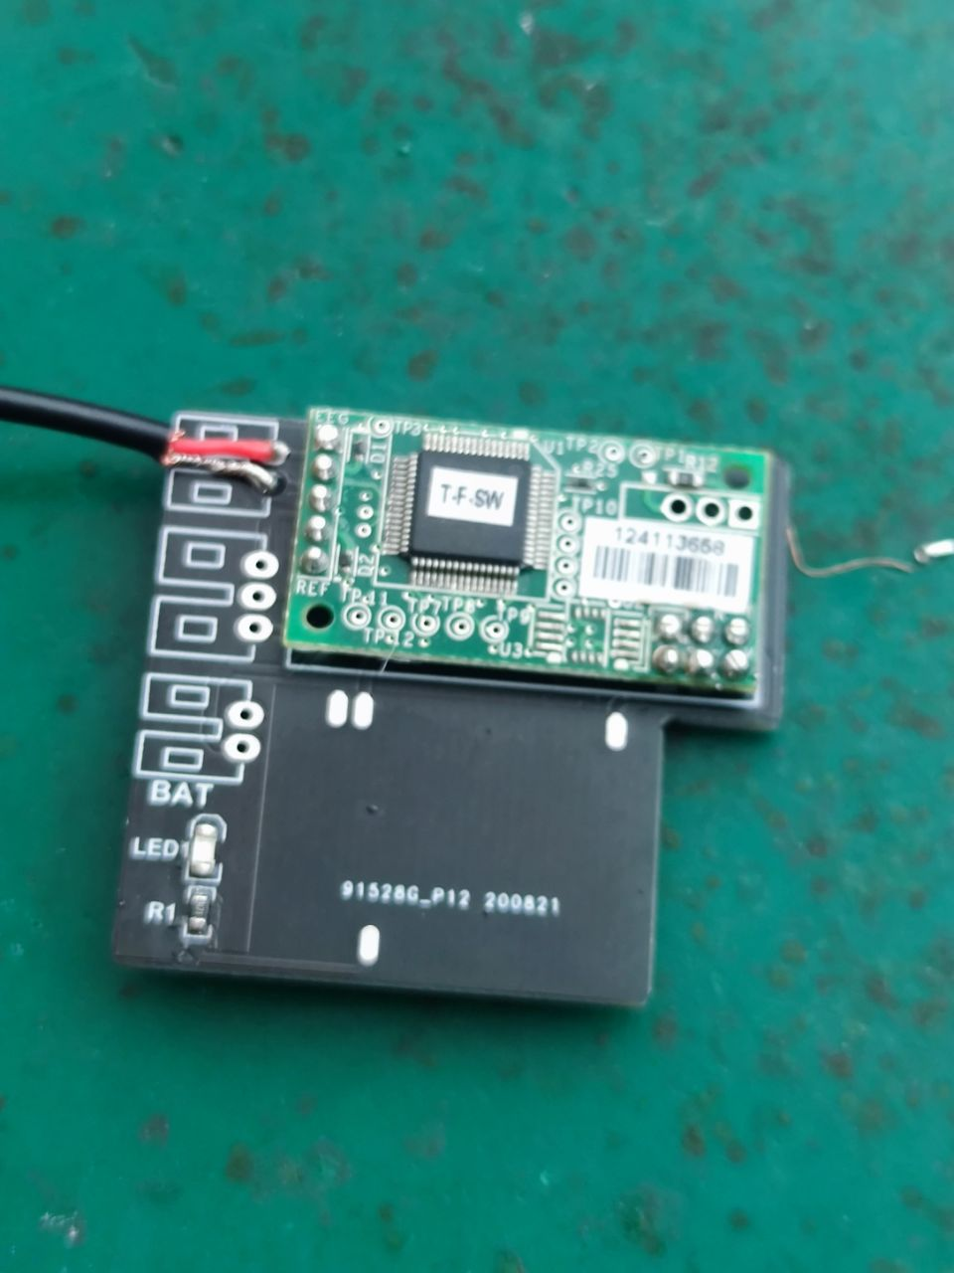
- Then take our the ear clip, weld it to the pins as shown.(Positive and negative poles have no sequential requirements.)
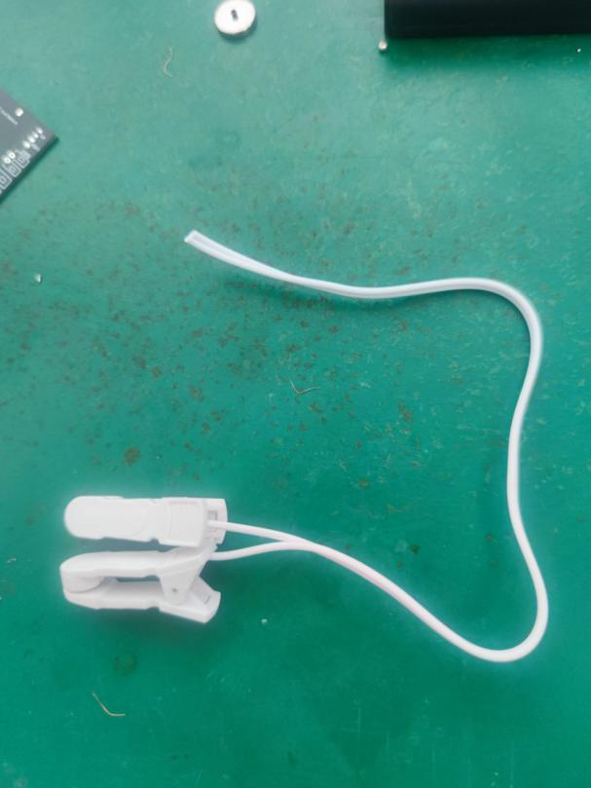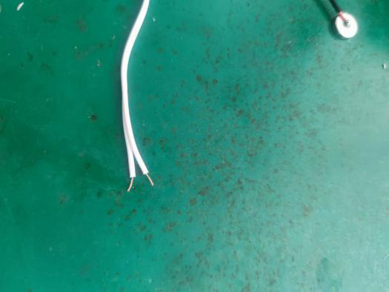
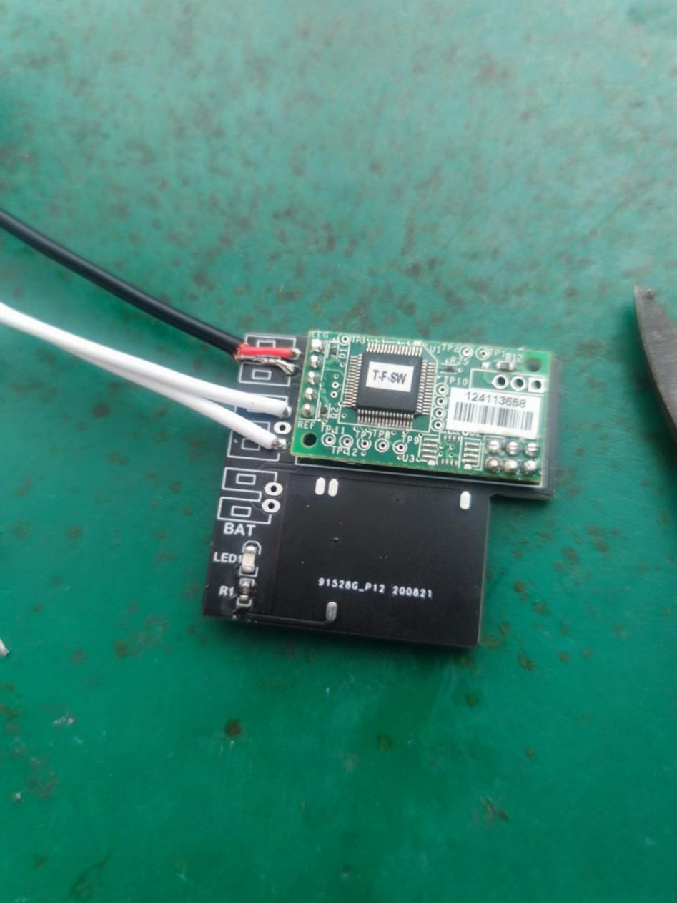
- At last, take out the battery case, weld it to the pins as shown.(notice the positive and negative poles)
